**Practical - 5**

**Aim:**

Write an assembly program to perform following logical operations on two variables A & B and save each result in separate variable.

* A ∧ B
* A ∨ B
* A⊗ B
* ~ A

Also check the result of A test B and compare its result with above operations.

**Description of instructions used:**

Instructions to perform logical operation

* **NOT** − Used to invert each bit of a byte or word.
* **AND** − Used for adding each bit in a byte/word with the corresponding bit in another byte/word.
* **OR** − Used to multiply each bit in a byte/word with the corresponding bit in another byte/word.
* **XOR** − Used to perform Exclusive-OR operation over each bit in a byte/word with the corresponding bit in another byte/word.

**1.AND:**

**Code:**

MOV AL, 11011010B

AND AL, 11110000B

RET

**Output:**

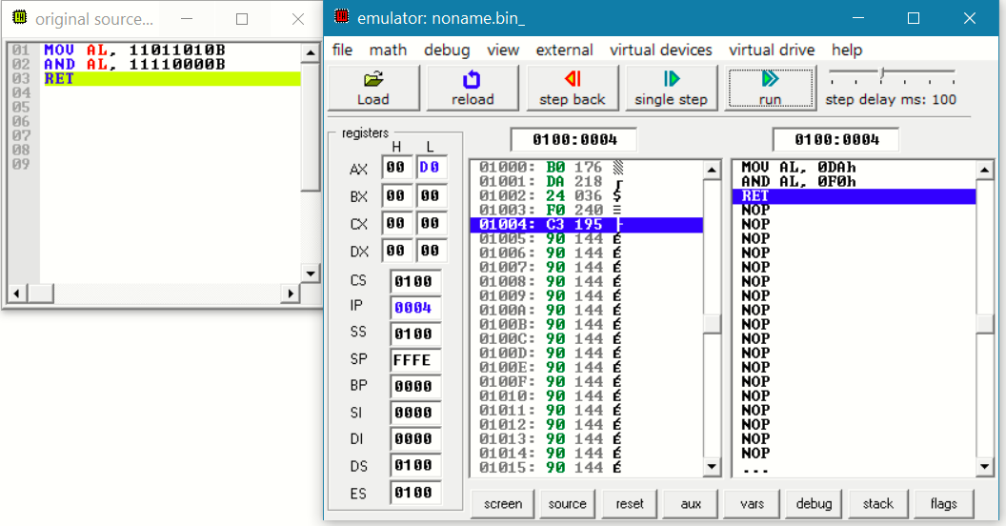

**2.OR:**

**Code:**

MOV AL, 11011010B

OR AL, 11110000B

RET

**Output:**

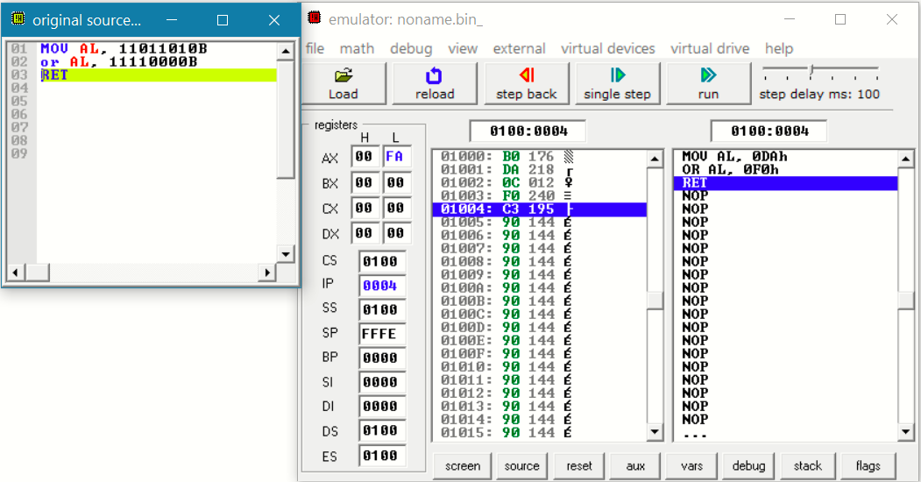

**3.XOR:**

**Code:**

MOV AL, 10101010B

XOR AL, 11110000B

RET

**Output:**

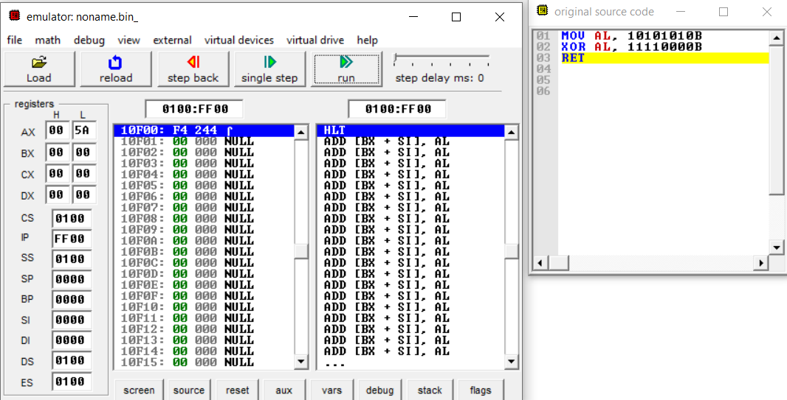

**4.NOT:**

**Code:**

MOV AL, 10101010B

NOT AL

RET

**Output:**

